Digital Forensics Laboratory
EXPERIMENT NO: 01 DATE: August 9, 2026
TITLE: Comprehensive Digital Evidence Acquisition and Command-Line Analysis using FTK Imager, WinPmem, and Volatility
1. AIM
To perform a complete forensic acquisition and analysis lifecycle by imaging non-volatile storage using AccessData FTK Imager, capturing live volatile memory (RAM) using the WinPmem command-line utility, and analyzing the extracted memory dump using Volatility 3 commands via the PassMark Volatility Workbench.

2. SOFTWARE / TOOLS REQUIRED
- Operating System: Windows OS
- Forensics Tools:
  - AccessData FTK Imager (GUI for non-volatile physical drive imaging)
  - WinPmem (winpmem_mini_x64_rc2.exe) (CLI tool for volatile memory capture)
  - Volatility 3 Framework (vol.exe / PassMark Volatility Workbench V3.0)
- Hardware: Evidence PC/Workstation, Target Storage Drive (hp v221w 16GB USB Device).

3. THEORY
A thorough digital forensic investigation requires collecting both data at rest and data in motion using strict operational procedures.
- Non-Volatile Memory Acquisition: AccessData FTK Imager creates mathematically verifiable, bit-by-bit physical images of storage devices (saved as Raw/dd) without altering the original evidence.
- Volatile Memory (RAM) Acquisition: Command-line utilities like WinPmem load a specialized kernel driver (pme98A2.tmp) to read physical memory directly. Executing this via CMD writes active processes, network connections, and decrypted keys to a raw dump file (.raw).
- Volatile Memory Analysis (CLI): Volatility 3 is a framework for analyzing RAM dumps. By passing specific parameters and plugins (e.g., -f <image_path> windows.pslist.PsList) into the command line or workbench, investigators can reconstruct the system's live state and identify suspicious processes.

4. PROCEDURE
Part A: Acquiring Non-Volatile Memory (Disk Image) using FTK Imager
Step 1: Select the Source Type
Open FTK Imager as an Administrator. Navigate to File > Create Disk Image. In the Select Source dialog, choose Physical Drive.
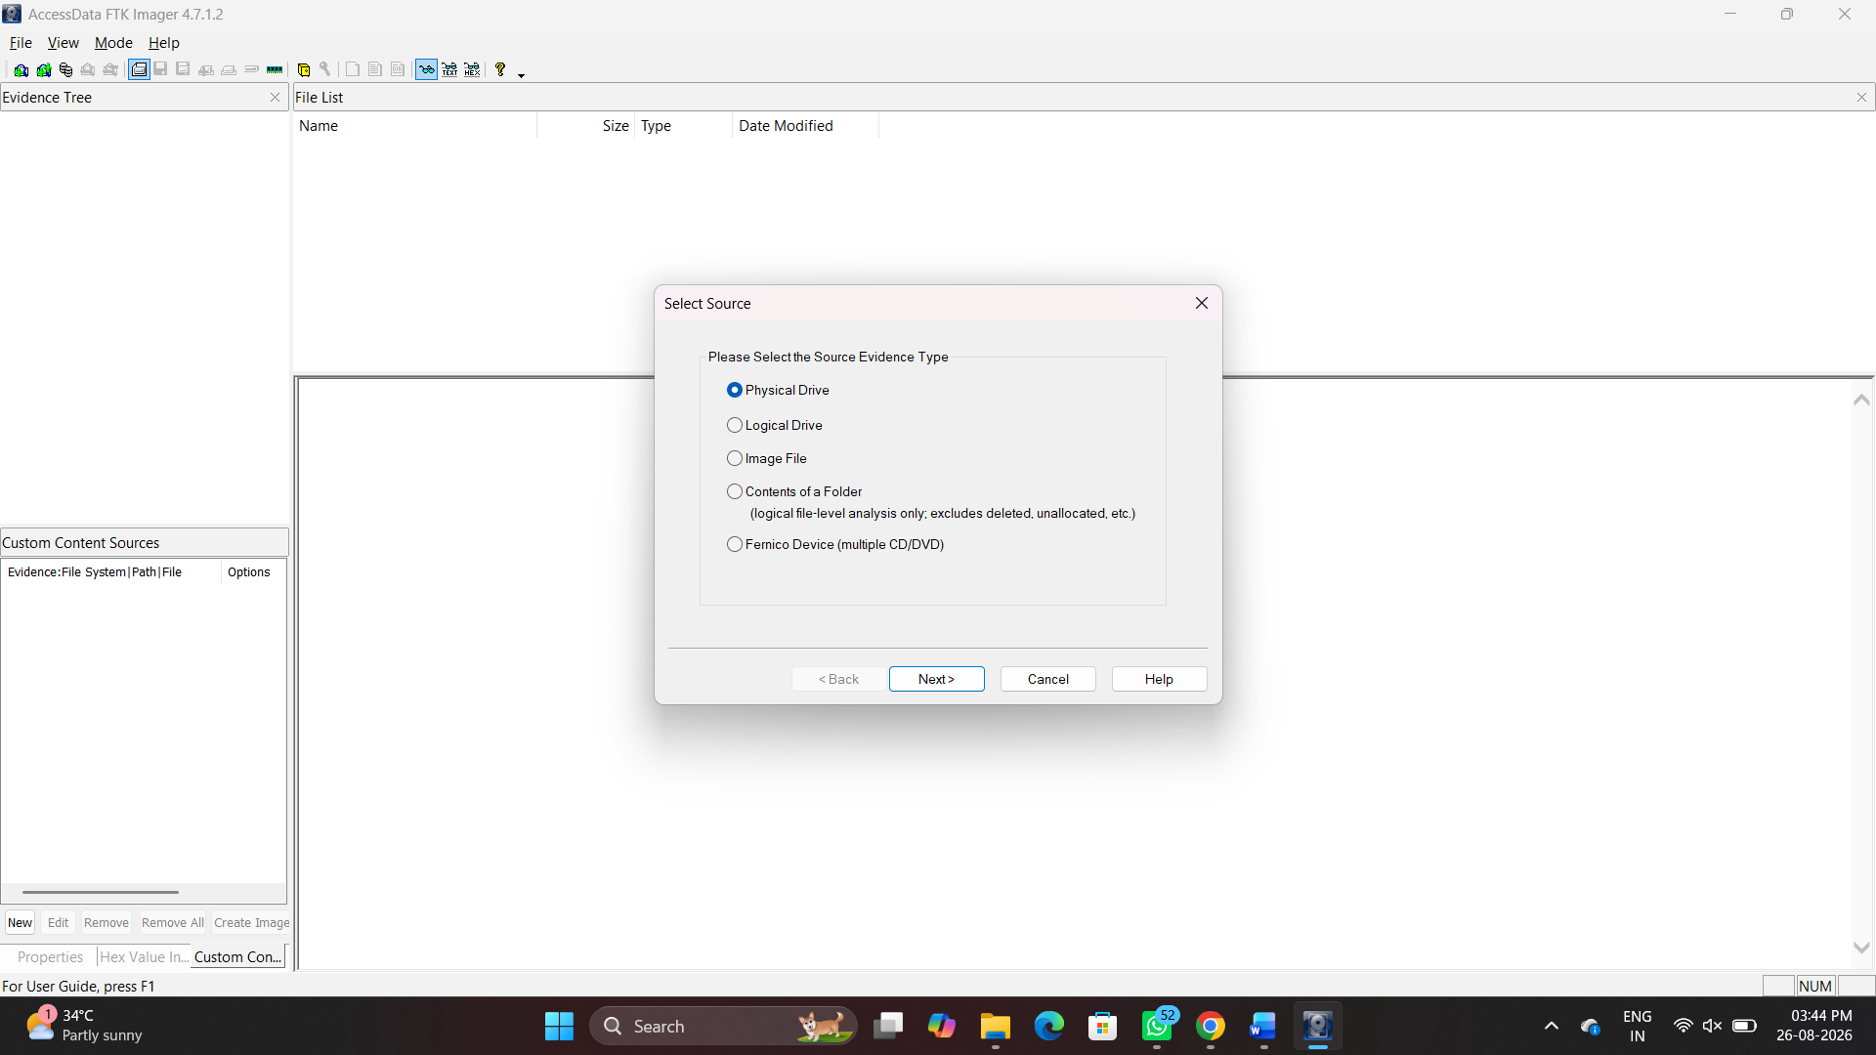Figure 1: Selecting Physical Drive as the source evidence type
Step 2: Select the Specific Drive
Select the target evidence drive (\\.\PHYSICALDRIVE1 - hp v221w USB Device [16GB USB]) from the dropdown.
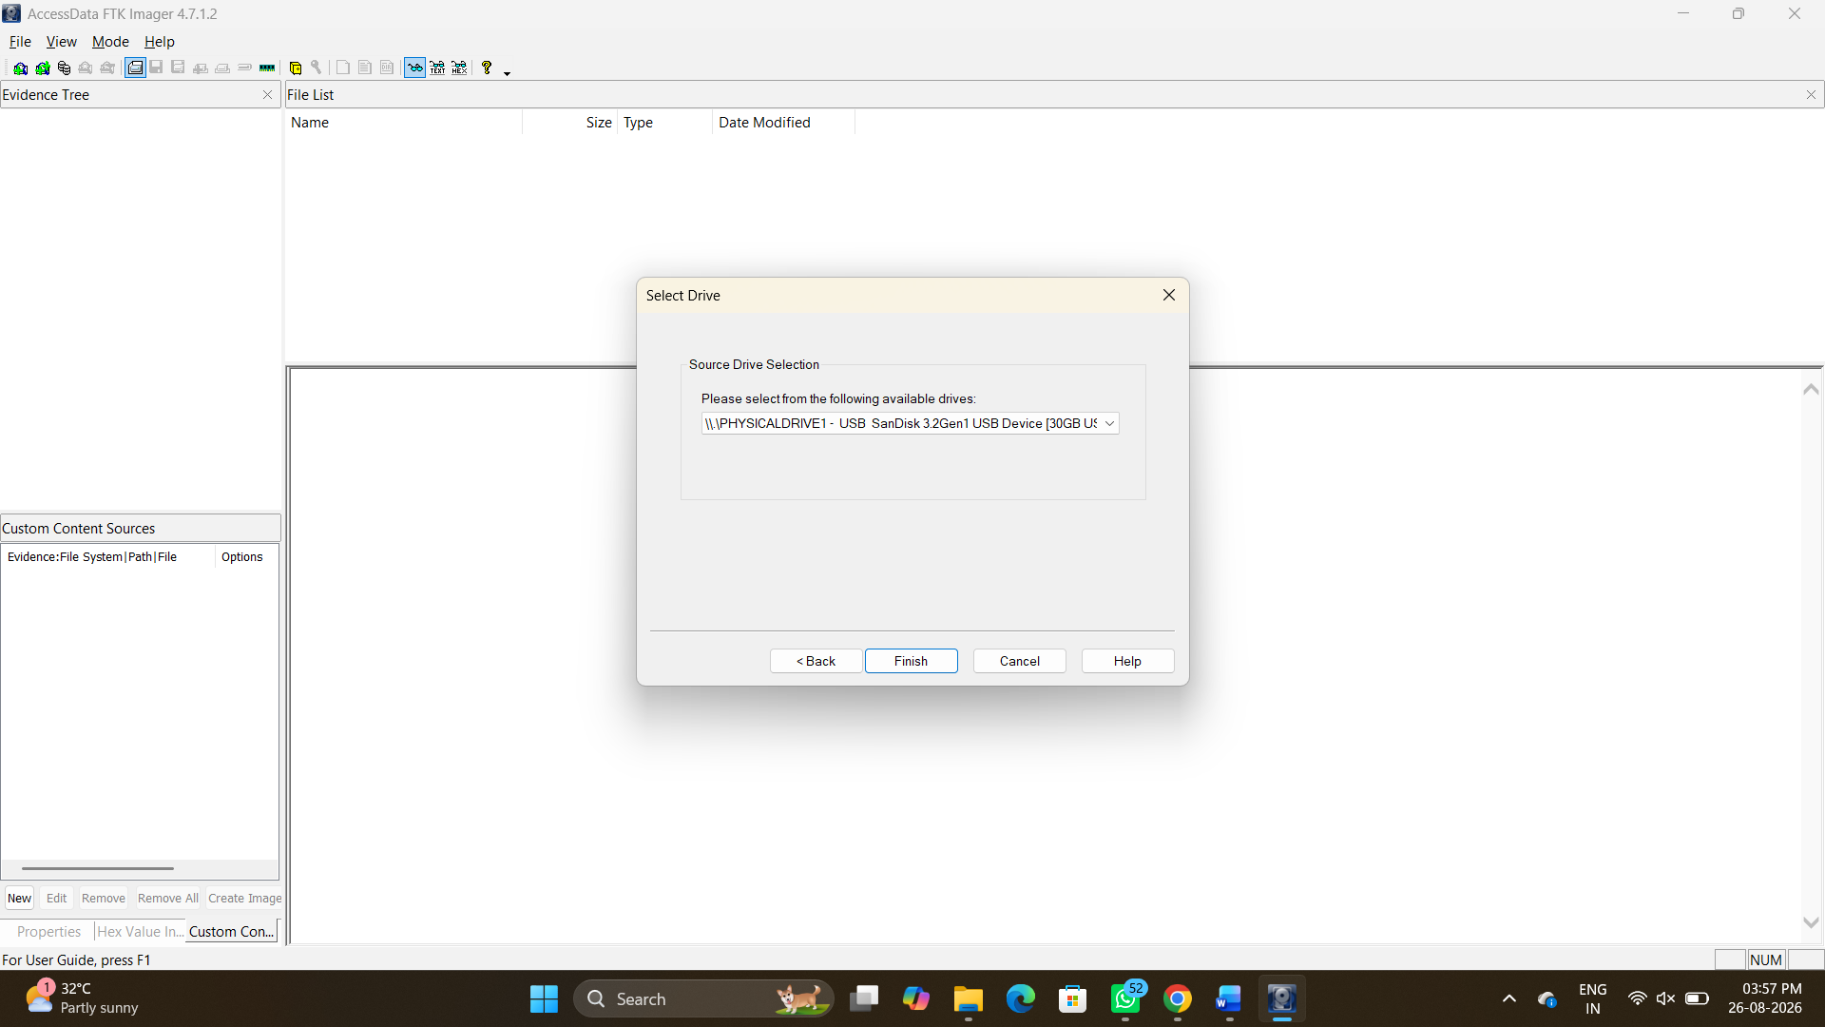
Figure 2: Selecting the target USB device for acquisition
Step 3: Choose the Image Type
Select Raw (dd) as the destination image type to create a pure bitstream copy.
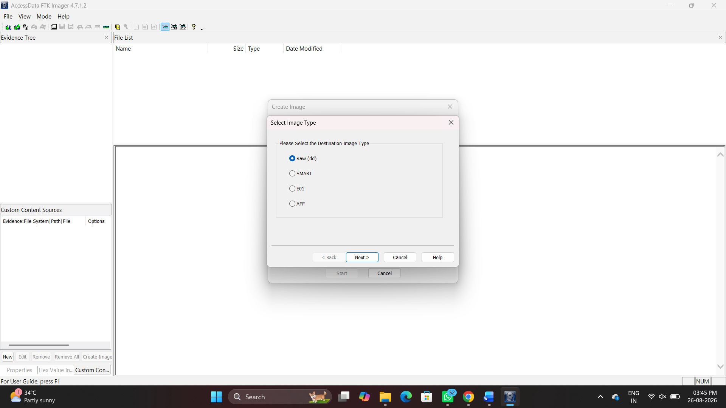
Figure 3: Configuring the destination image format to Raw (dd)
Step 4: Enter Evidence Item Information
Provide the standardized case details to maintain the chain of custody:
- Case Number: 01
- Evidence Number: 01
- Unique Description: Examine
- Examiner: Aasif Ahmed A

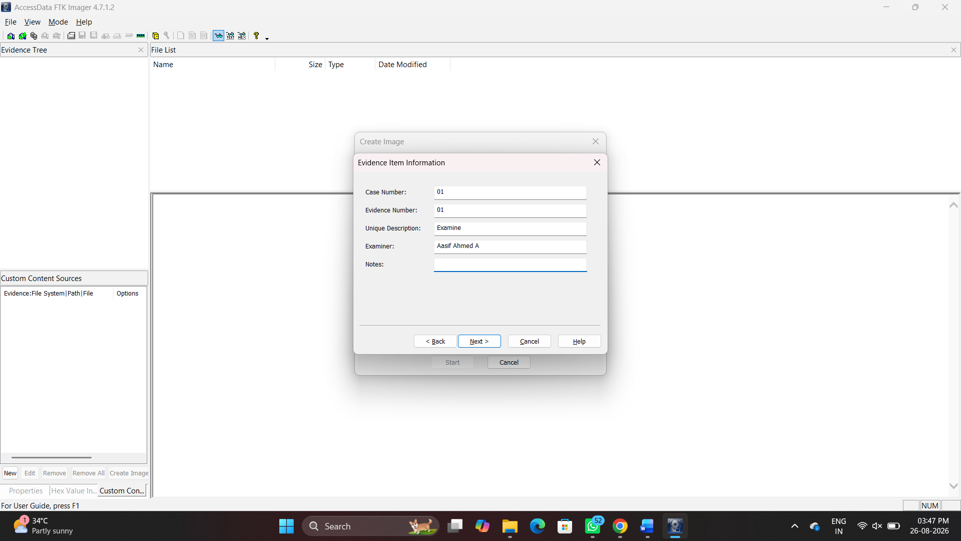
Figure 4: Entering the forensic case and examiner details

Step 5: Configure Image Destination
Set the destination folder to A:\DF\Digital_Forensics_Lab\Experiment-01-FTK-Imager\Results and the filename to Result. Set the Fragment Size to 20 MB and check Verify images after they are created.
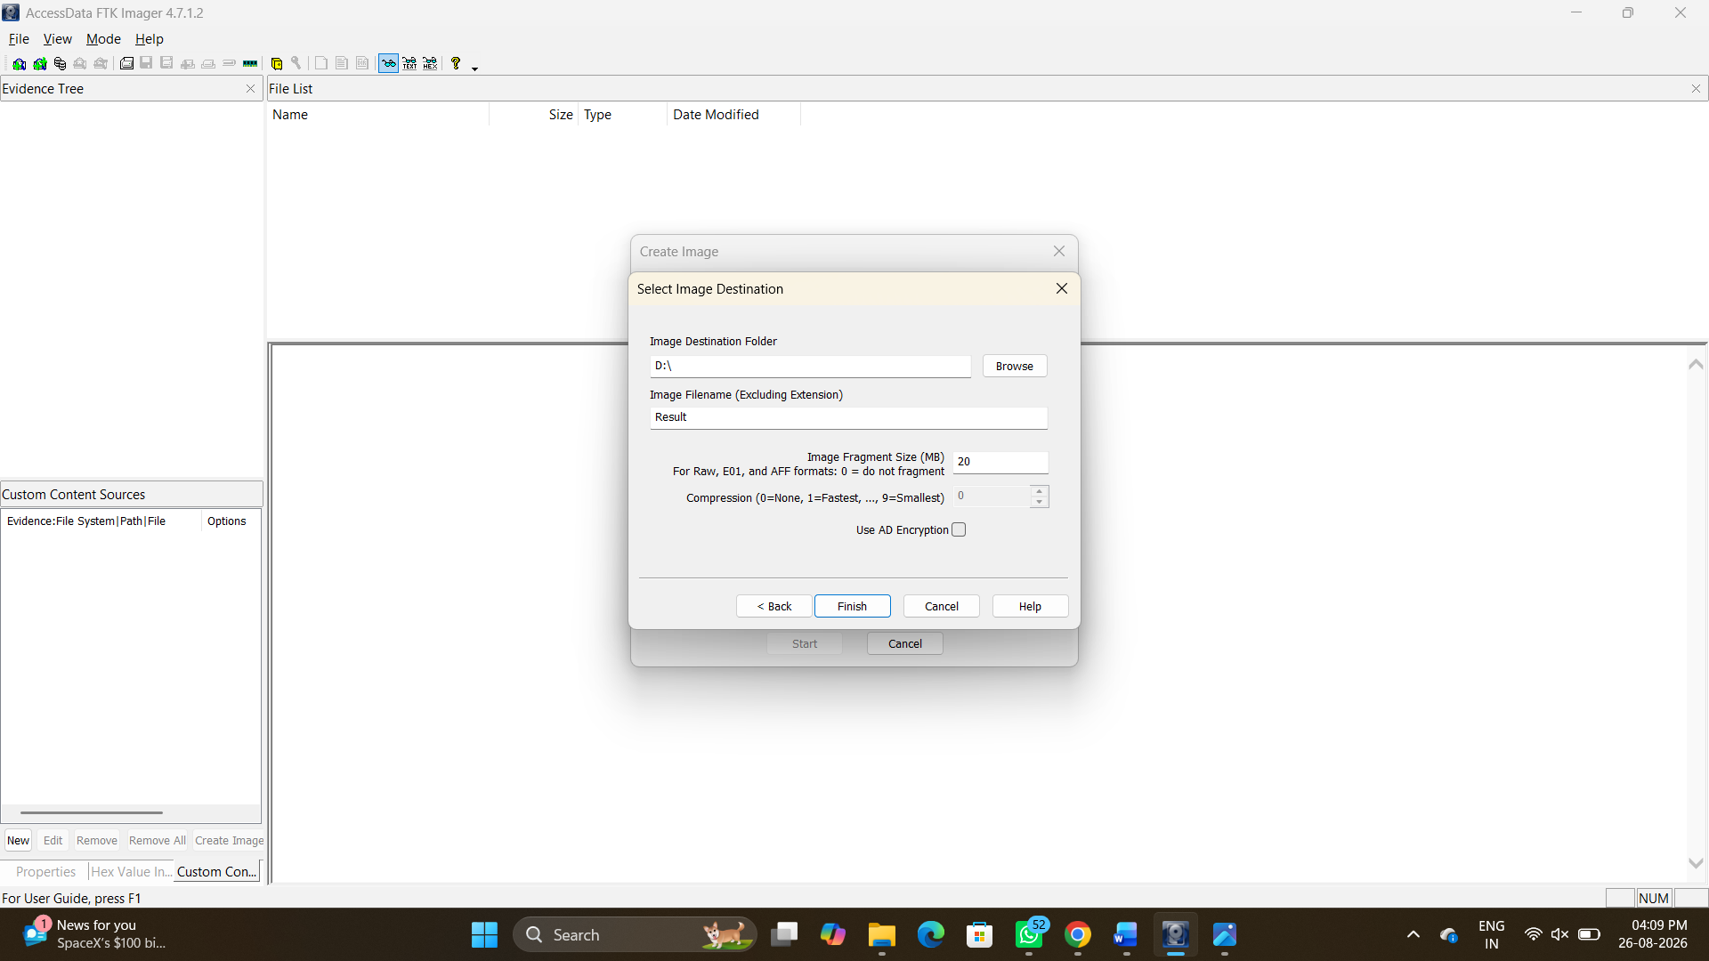
Figure 5: Setting the destination path, filename, and fragmentation size
Step 6: Monitor Acquisition Progress & Hash Verification
Click Start. Once complete, FTK Imager hashes the original drive and the newly created image. Review the Drive/Image Verify Results.
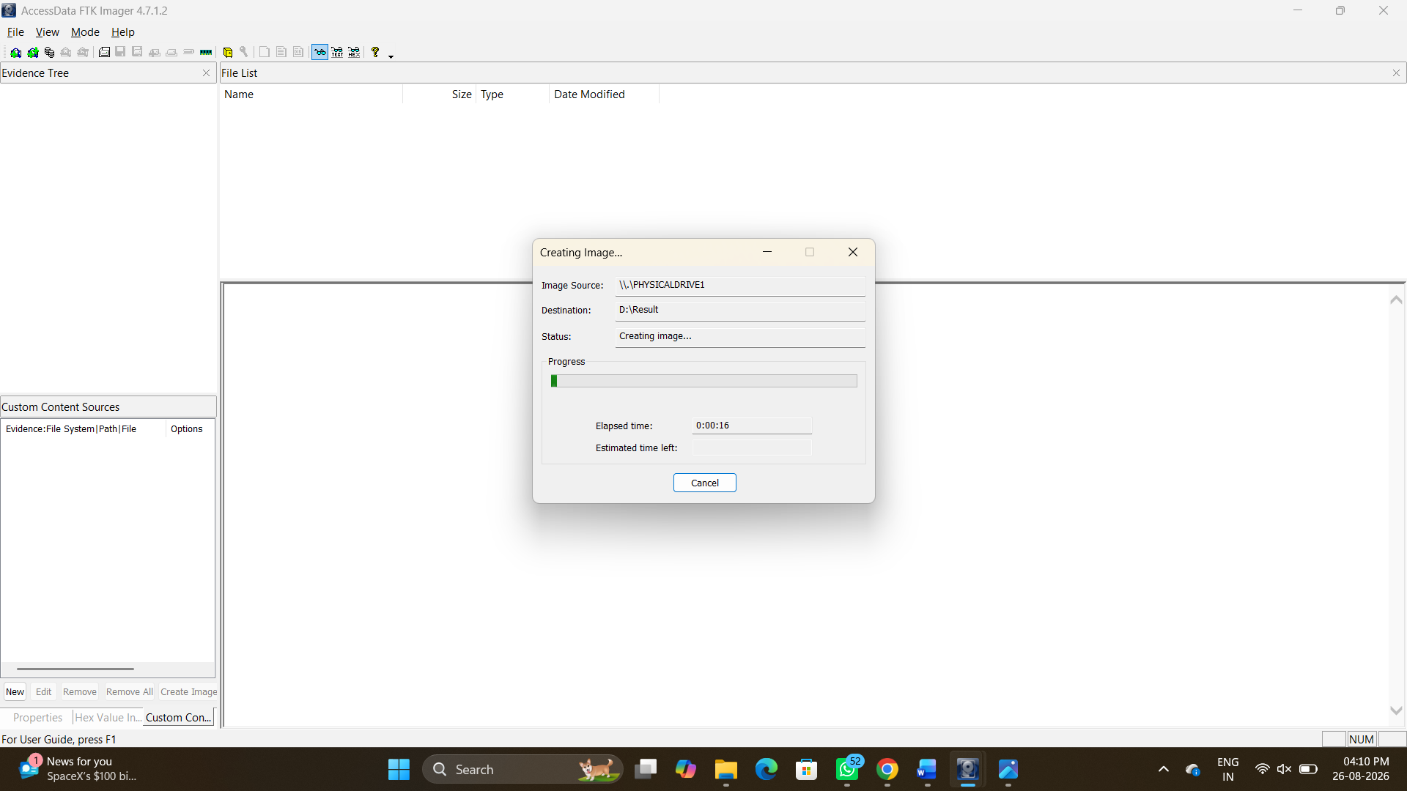
Figure 6: Disk imaging progress tracking
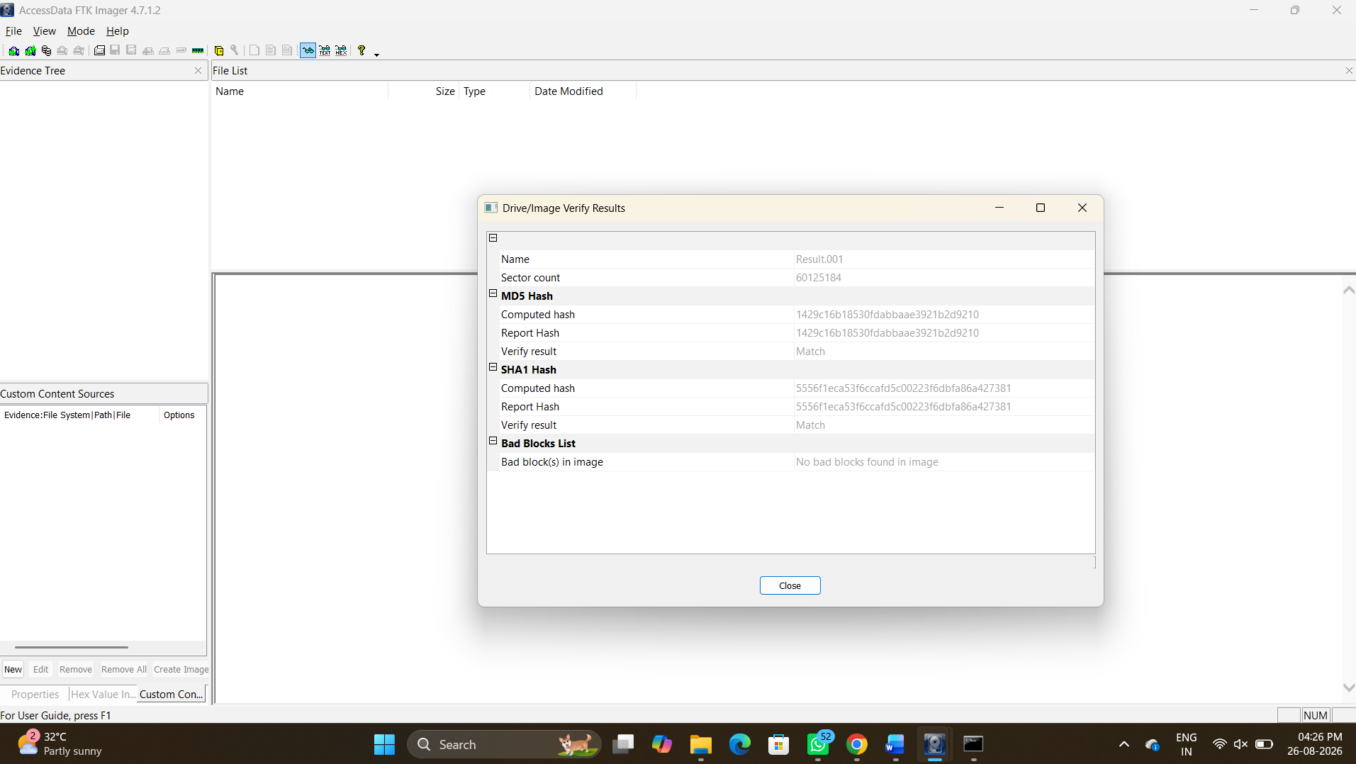Figure 7: Successful verification of MD5 and SHA1 hashes
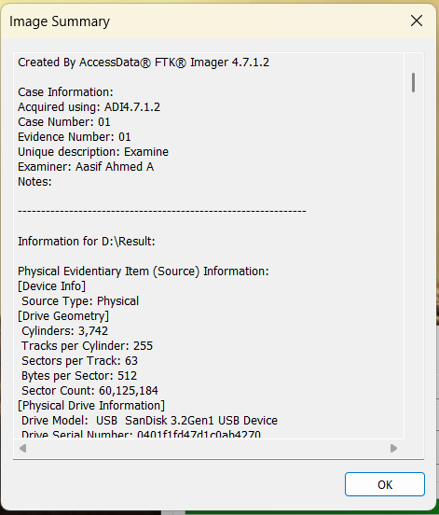
Figure 8: Image Summary detailing the physical device geometry
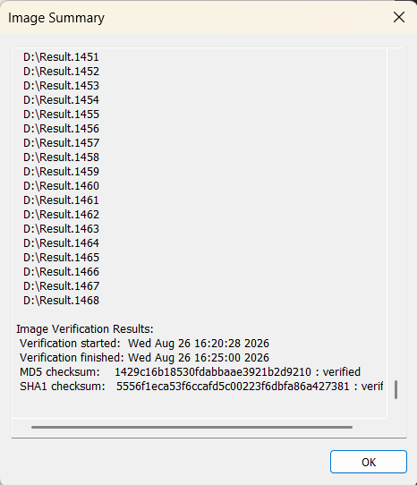
Figure 9: Image Summary detailing the hash verification results and segment list

5. CONCLUSION
- Disk Imaging (FTK Imager): Successfully acquired a bit-by-bit physical image (Result.raw) of the 16GB USB drive. Data integrity was confirmed through matching pre- and post-acquisition MD5/SHA-1 hash verification.
- RAM Capture (WinPmem): Successfully dumped live volatile physical memory via the command-line interface, preserving active runtime state data.
- Memory Analysis (Volatility 3): Analyzed the captured .raw dump using Volatility 3 plugins (windows.pslist) to reconstruct live system processes and runtime artifacts.

